

M.Sc. Computer Science and Engineering

Hypermedia Applications Project

Leoni Luca 10574709

Minotti Luca 10572239

Ratti Francesco 10640265

www.ourcompany.com

Design Document

23rd March 2021

Version 1.0

**Abstract**

Something

**Authors**

**Francesco Ratti**

*MSc Computer Science and Engineering*

[francesco2.ratti@mail.polimi.it](mailto:francesco2.ratti@mail.polimi.it)

+39 3342546426



**Luca Minotti**

*MSc Computer Science and Engineering*

[luca2.minotti@mail.polimi.it](mailto:luca2.minotti@mail.polimi.it)

+39 3315228707



**Luca Leoni**

*MSc Computer Science and Engineering – EIT Digital Human Computer Interaction and Design*

[luca3.leoni@mail.polimi.it](mailto:luca3.leoni@mail.polimi.it)

+39 3484124137



**Contents**

Plug-IT 5

Interactive Dialogue Model 6

Content Design 6

C-IDM in the large 6

C-IDM in the small 6

Navigation Design 8

Mapping Content Tables into Pages 8

Links in topic pages 9

# Plug-IT

ICT COMPANY

Minimum Requirements

**Contents** are about:

* The company in general
* People (>20)
* Areas (>3)
* Products or services (>30)

Some **relationship** must be evident on the website:

* People are RELATED to Areas (and VICEVERSA) in different ways, e.g., because they are RESPONSIBLE of an area or WORK in an area
* People are RELATED to Products/services (and VICEVERSA) in different ways, e.g., because they are PROJECT MANAGER for a product, or are REFERENCE FOR ASSISTANCE of a product/service
* Products are RELATED to the Area (the Area it BELONGS to) and Areas are RELATED to the products OFFERED for each area

# Interactive Dialogue Model

## Content Design

### C-IDM in the large

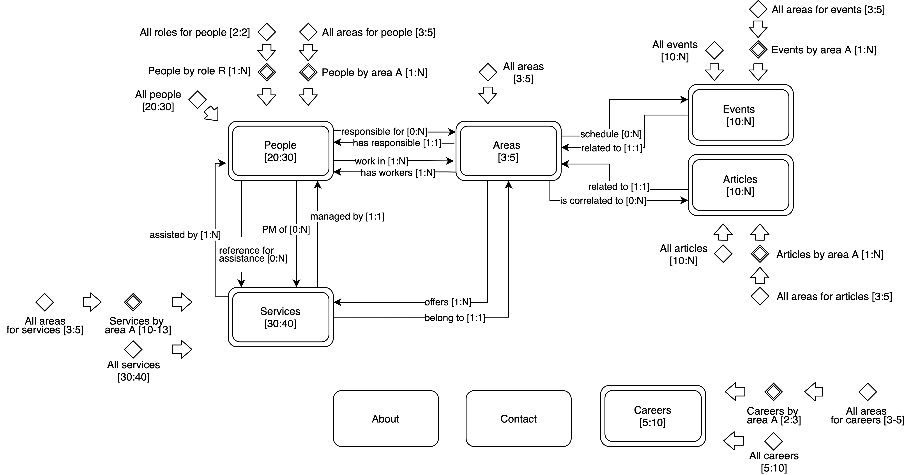

### C-IDM in the small

|  |
| --- |
| **KIND OF TOPIC:** *People* |
| Person name: text (max 45 char) |
| Person image: image |
| Person bio: text (max 100 words) |
| Peron roles: list of roles (name) |
| Person areas: list of areas (name) |

|  |
| --- |
| **KIND OF TOPIC:** *Areas* |
| Area name: text (max 45 char) |
| Area overview: text (max 50 words) |
| Area detailed description: text (max 500 words) |
| Area responsible: person (name) |
| Area team: list of people (name) |
| Area events: list of people (name) |
| Area articles: list of articles (title, image, overview) |
| Area products/services: list of services (name, image, overview) |

|  |
| --- |
| **KIND OF TOPIC:** *Services* |
| Service name: text (max 45 char) |
| Service area: area (name) |
| Service overview: text (max 100 words) |
| Service project manager: people (name) |
| Service reference assistants: list of people (name) |

|  |
| --- |
| **KIND OF TOPIC:** *Events* |
| Event title: text (max 45 char) |
| Event image: image |
| Event area: area (title) |
| Event description (max 100 words) |
| Event date/time: date/time |
| Event location: location |

|  |
| --- |
| **KIND OF TOPIC:** *Articles* |
| Article title: text (max 45 char) |
| Article image: image |
| Article area: area (title) |
| Article text: text (max 1000 words) |
| Article author: text (max 45 char) |
| Article date: date |

|  |
| --- |
| **TOPIC:** *About* |
| Company overview: text (500 words) |
| Scope: list of areas (name, responsible name) |

|  |
| --- |
| **TOPIC:** *Contacts* |
| Office information: [address, phone, email] |
| Map view: map |
| Contact form: form |

|  |
| --- |
| **KIND OF TOPIC:** *Careers* |
| Position name |
| Position area |
| Position overview: text (max 100 words) |
| Office location |

## Navigation Design

### Mapping Content Tables into Pages

|  |
| --- |
| **KIND OF TOPIC:** *People* |
| Person name: text (max 45 char) |
| Person image: image |
| Person bio: text (max 100 words) |
| Peron roles: list of roles (name) |
| Person areas: list of areas (name) |

**KIND OF TOPIC:** *People*

|  |
| --- |
| **PAGE:** |
|  |
|  |
|  |

**KIND OF TOPIC:** *Areas*

|  |
| --- |
| **PAGE:** *Area page* |
| Area name: text (max 45 char) |
| Area overview: text (max 50 words) |
| Slider showing most recent content (articles, events, services) |
| Detailed description: text (max 500 words) |

**KIND OF TOPIC:** *Services*

|  |
| --- |
| **PAGE:** *Specific-area services overview* |
| Area name |
| Grid of services [name, image, overview (max 30 words)] |
| Related contents (articles, events) |

|  |
| --- |
| **PAGE:** *Service page* |
| Service name |
| Service image |
| Service description (max 100 words) |
| Images |
| Project manager: Person (name) |
| Reference assistants: list of Person (name) |
| Related contents (articles, events, services) |

**KIND OF TOPIC:** *Events*

|  |
| --- |
| **PAGE:** *Events’ Calendar* |
| Grid of upcoming events [name, area, date/time, image, overview (max 30 words)] |

|  |
| --- |
| **PAGE:** *Event Page* |
| Event title: text (max 45 char) |
| Event image: image |
| Event area: Area (title) |
| Event description (max 100 words) |
| Event date/time: date/time |
| Event location: location |

**KIND OF TOPIC:** *Articles*

|  |
| --- |
| **PAGE:** *Specific-area Articles Overview* |
| Area name |
| Grid of articles [title, image, overview (max 30 words)] |

|  |
| --- |
| **PAGE:** *Article Page* |
| Article title: text (max 45 char) |
| Article image: image |
| Article area: Area (title) |
| Article text: text (max 1000 words) |
| Article author: text (max 45 char) |
| Article date: date |
| Related contents (articles, events, services) |

**TOPIC:** *About*

|  |
| --- |
| **PAGE:** *About Page* |
| Company overview: text (500 words) |
| Scope: list of Area (name, responsible name) |

**TOPIC:** *Contacts*

|  |
| --- |
| **PAGE:** *Contacts Page* |
| Office information: [address, phone, email] |
| Map view: map |
| Contact form: form |

**KIND OF TOPIC:** *Careers*

|  |
| --- |
| **PAGE:** *Careers Page* |
| Available position: [position name, position area, image, overview, office location, form] |

|  |
| --- |
| **PAGE:** *Career Page* |
| Position name |
| Position area |
| Position overview: text (max 100 words) |
| Office location |
| Contacts |

### Links in topic pages